Random Forest — Heart Failure Dataset | Machine Learning & AI | Student: Ammar

Objective  Apply Random Forest classification on the Heart Failure Clinical Records dataset to predict patient mortality (DEATH_EVENT) and evaluate model performance using a Confusion Matrix. | Algorithm Overview  Random Forest builds multiple decision trees (ntree=100) and merges their majority-vote predictions. It reduces overfitting, handles imbalanced data well, and exposes feature importance via importance=TRUE.

R Code Implementation

1. Load & Prepare  data <- read.csv(file.choose())  library("randomForest")  data$DEATH_EVENT <-  as.factor(data$DEATH_EVENT)  2. Train / Test Split (80 / 20)  set.seed(123)  train_index <- sample(1:nrow(data),  0.8 * nrow(data))  train_data <- data[train_index, ]  test_data <- data[-train_index, ]  3. Train Random Forest Model  model <- randomForest(  DEATH_EVENT ~ .,  data = train_data,  ntree = 100,  importance = TRUE)  print(model)  4. Predict & Accuracy  predictions <- predict(model, test_data)  accuracy <- sum(predictions ==  test_data$DEATH_EVENT) / nrow(test_data)  print(accuracy)  5. Plot Confusion Matrix  library(ggplot2)  cm <- table(Predicted = predictions,  Actual = test_data$DEATH_EVENT)  cm_df <- as.data.frame(cm)  ggplot(data = cm_df,  aes(x=Actual, y=Predicted,  fill=Freq)) +  geom_tile(color = "black") +  geom_text(aes(label=Freq), size=6) +  scale_fill_gradient(  low="lightblue", high="blue") +  labs(title="Confusion Matrix -  Random Forest") +  theme_minimal() | Confusion Matrix Output  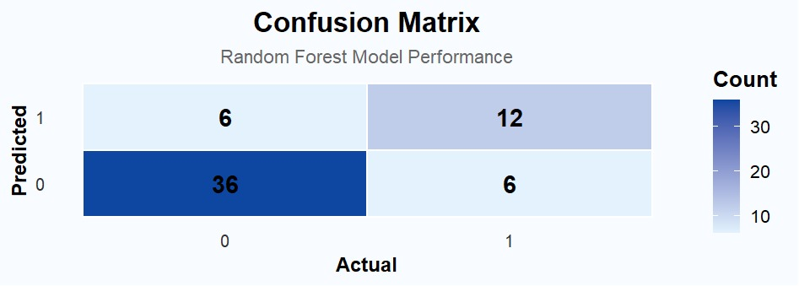  Derived Metrics (from matrix)  Metric Formula Value  Accuracy (TN+TP)/Total 80.0 %  Precision TP/(TP+FP) 66.7 %  Recall TP/(TP+FN) 66.7 %  F1-Score 2×P×R/(P+R) 66.7 %  Matrix Breakdown  Cell Count / Meaning  TN (Pred=0, Act=0) 36 — Correctly predicted survived  TP (Pred=1, Act=1) 12 — Correctly predicted death  FP (Pred=1, Act=0) 6 — Predicted death, survived  FN (Pred=0, Act=1) 6 — Predicted survived, died

Conclusion
The Random Forest model (ntree=100, 80/20 split) achieved 80% accuracy on the Heart Failure test set. The confusion matrix shows 36 TN and 12 TP (correct predictions) against 6 FP and 6 FN (misclassifications). Balanced Precision and Recall of 66.7% suggest the model handles both classes reasonably, with scope for improvement via hyperparameter tuning or SMOTE oversampling for the minority death class.

